Sam McDowell

7/15/2020

Lab 5.1

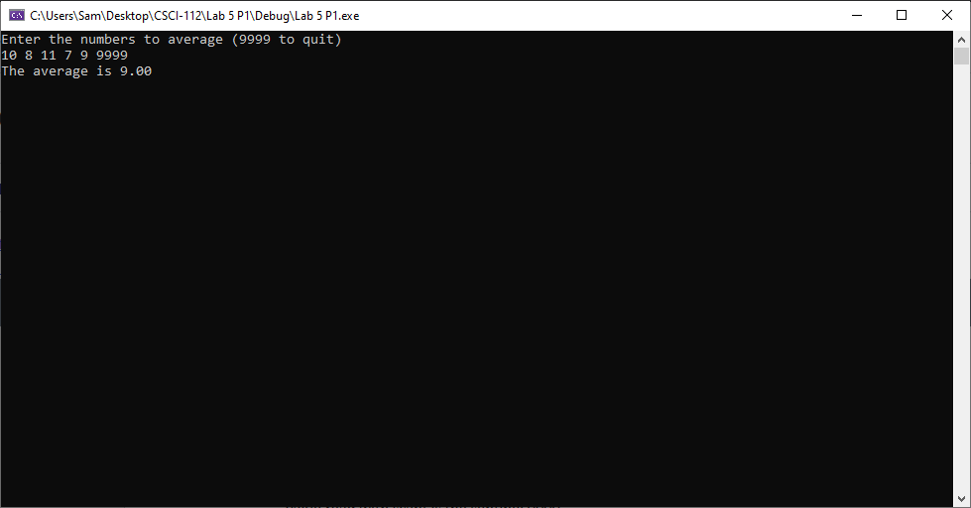

# Transcription:

Enter the numbers to average (9999 to quit)

10 8 11 7 9 9999

The average is 9.00